Team Eat Nomz

Milestone 3 Part 2d

We have identified two key pages on eatnomz.com that have the highest potential of improving the website’s user experience and revenue. Those two pages are the collection page (/collection/all) and the home page (eatnomz.com). We recommend the implementation of two A/B test experiments that will improve features on those two pages.

The first experiment is on the collection page. We have identified the collection page as the most important page on eatnomz.com. Not only it is visited by most customers who ended up converting, it also exposes many customers to products provided by Nomz for the first time. Therefore, an informative collection page will greatly increase Nomz’s conversion rate.

However, currently the collection page does not offer a clear message directing customers to the page of a specific product, which will provide confusion and reduce information accessibility of the website. Therefore, we recommend the addition of a “More Detail” button underneath the name of each product to provide more clarity to the customers.

At the same time, as identified in previous sections, customers have reflected that reviews are not accessible nor helpful on eatnomz.com. We believe placing a review feature on the collection page will greatly improve the accessibility of reviews on eatnomz.com. Therefore, we also recommend the addition of a review star element underneath the name of each product to make review more accessible. The A and B variation for this experiment is displayed in Appendix A.

Since Feb. 23rd, the home page has attracted 404 pageviews from viewers who live in the greater New York area, and visits to the homepage accounts for over 73.59% of all entrances on eatnomz.com. A well-designed and easily navigable home page is crucial to nomz because a great first impression will improve conversion rate drastically and further decrease bounce rate (currently at 42.30%).

However, according to the text analysis of our survey comments, the layout of the homepage provide negative impressions on some reviewers. This is most likely caused by the bulky product descriptions at the end of the home page that both subtract from the elegance and information readiness of the home page.

For this reason, we have proposed a A/B test that remove those bulky product descriptions and replace them with a “More Details” link directing viewers to the product page for more information. We believe this change will both reduce bounce rate on the homepage and improve overall conversion rate. The A and B variation of the test is displayed in Appendix B.

Both experiments will be conducted separately in two one-week intervals in succession to each other. In both experiments, 50% of the population will be given the original version of the website while the remaining 50% will be given the alternative version. Experiment on the collection page is currently live and the experiment on the homepage will be implemented a week later.

Appendix A: Collection Page A/B Testing

A setting: Current Collections Page

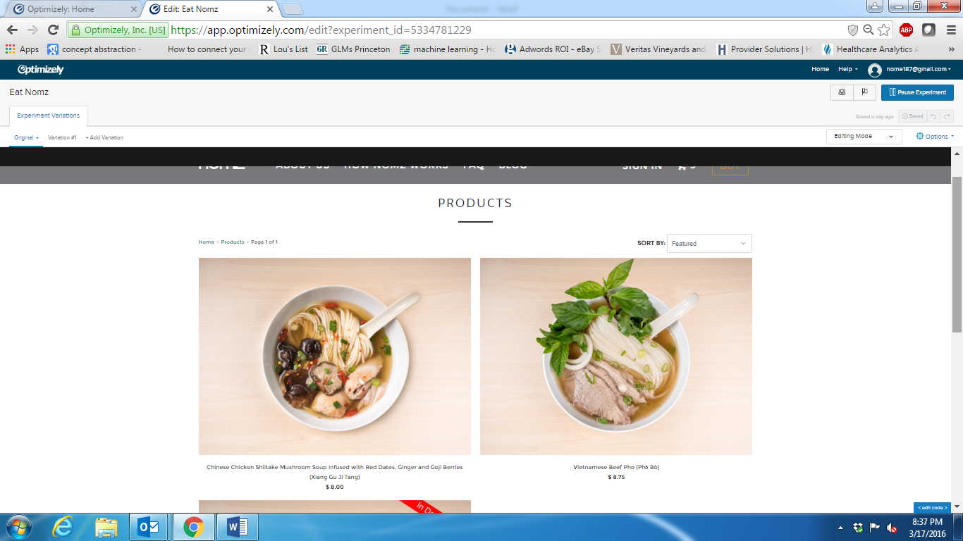

B setting (variation 1): New Proposed Collections Page with ratings, product name spaced out, and stronger call to action

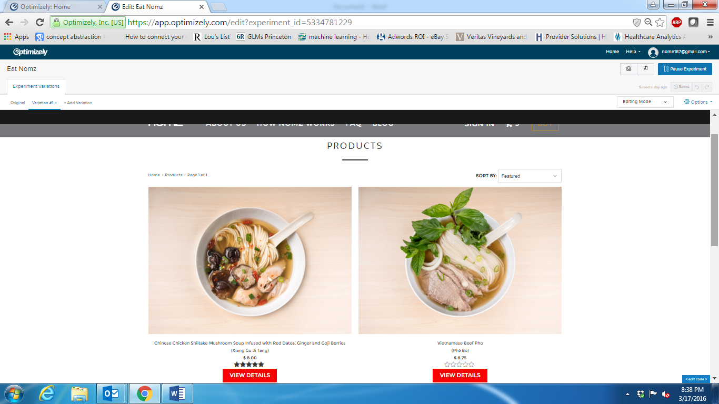

Appendix B: Home Page A/B Testing

A setting: Current Home Page

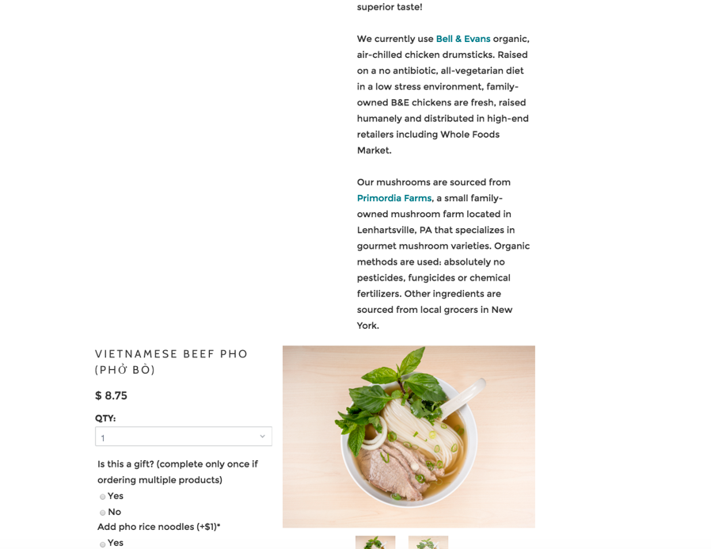

B setting (variation 1): New proposed home page with more concise layout

